RHYTHM OF THE REIN THERAPEUTIC RIDING PROGRAM
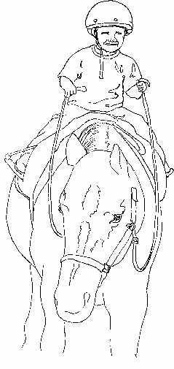
PO Box 67 386 US Rt.2 Marshfield, Vt. 05658 802 426 3781
rhythmoftherein@aol.com
Direct inquiries about becoming a participant or about the scholarship application to Dianne Lashoones, Program Director at any of the above contact information sites.

RHYTHM OF THE REIN SCHOLARSHIP FUND FINANCIAL AID APPLICATION

POLICIES

All information provided will be held in strictest confidence. It is our mission to offer our services to everyone who is accepted into our program regardless of ability to pay.

Our board of directors has responsibility to our donors to insure scholarship monies are well managed and appropriately spent, therefore it is our policy that the scholarship committee will review all requests for financial aid via the Financial Aid Application.

All applicants must completer the ENTIRE APPLICATION and submit proof of financial eligibility (copy of most recent federal or state tax return, SSI or Disability check.)

Scholarships are provided on a financial NEED basis and on a first come first serve basis until all scholarship monies are allocated or spent. Awards are received as credit to sessions.

Sessions cancelled by the participant or his/her legal guardian less than 24 hours before the session will be billed at the full amount and scholarship funds will not be applied to no-shows.

Rhythm of the Rein reserves the right to rescind scholarship awards as it sees fit.

Rhythm of the Rein reserves the right to waive specific requirements on a case by case basis.

Scholarships are granted for 12 sessions.

SCHOLARSHIP APPLICATION FORM

ALL INFORMATION PROVVIDED HELD IN STRICTEST CONFIDENCE

Name of Rider__________________________DOB___________Date of Request________
Have you applied before?_________________If so, when? __________________________
Are other family members applying for this same aid? Yes ___ no ___

Information below applies to parent/guardian or adult rider

Name______________________________Phone- Home__________Work__________

Spouse_____________________________Phone-Home___________Work___________

Address___________________________City________________State_____Zip______

Married_______Single__________Divorced/Separated___________Widow__________

Rider resides with Both Parents____ Mother ___ Father ___ Guardian ___ Self ____

The following information is required for financial aid. Please list all forms of income received annually. Mark N/A for any that do not apply to you. Also attach proof on income (most recent state or federal tax return, SSI or Disabiliy check as required by
Rhythm of the Rein’s scholarship policy. You will be notified if your request has been approved within 30 days of receipt of completed application.

Wages Alimony/Spousal Support
Interest from savings Welfare/General Assistance
Social Security Benefits Pension/Retirement
VA Benefits Insurance Benefits
Medicaid Respite Care/Flexible Funds
Unemployment Benefits Disability/Workers Comp
Child Support Income Other

Please describe any unusual circumstances (debts, illness, unemployment, etc) that contribute to you need for assistance below.

____________________________________ _________________
Signature Date

----------------------------------------------------------------------------------------------------
OFFICE USE ONLY
Amount Granted ____________________-Date ____________

