RHYTHM OF THE REIN THERAPEUTIC RIDING PROGRAM
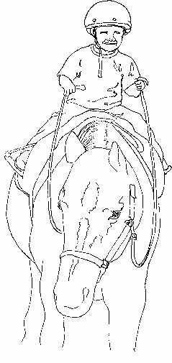
PO Box 67 386 US Rt.2 Marshfield, Vt. 05658 802 426 3781
info@rhythmoftherein.org
www.rhythmoftherein.org

T
RIDER PAYMENT AND SCHEDULING PLAN

Fees are $85/ individual, contract for groups, payable to Rhythm of the Rein

Name of Participant __________________________________________________

Name of Parent or Guardian (if applicable) ________________________________

Daytime phone ________________________evening phone __________________

THESE SESSIONS WILL BE PAID BY (check all that apply)
- Direct Pay ____per session _______monthly
- Direct Pay : send invoice to : ____________________________________
Mailing address _____________________________________
______________________________________
- Third Party: I have contacted the party below and have approval
To verify and arrange for payment please contact :
Agency/School: ______________________________________
Contact Name ________________________________________
Phone number ________________________________________
Mailing Address _______________________________________
________________________________________

SCHEDULING INFORMATION

Age ____________ Weight _____________ Height _______________

Please indicate days and times you are not available. The more flexibility you have the easier it will be to schedule your sessions. Sessions run from 45 min to an hour.

Days unavailable ______________________________________
Times unavailable _____________________________________

